**Team leader:**

Ben Zhang:          A00976551

**Team members:**

Andrew Main:     A00815430

Phat Le:               A01012144

Simon Shoban:    A00985653

Cameron Roberts:  A00966003

**Milestone 3 – Skeleton website**

**Game Review 8™ Game Review Web System**

**COMP 1536 Group 6**

**Date: 02-15-2017**

**Table of Contents**

**1. Overview**

1.1 Link

1.2 List of items completed

        1.3 Additional work

**2. Documentation of work**

2.1 Screenshots of front page

        2.2 Screenshots of table

2.3 Screenshots of form

**3. Key issues**

3.1 Encountered problems

3.2 Outstanding problems

**4. Testing**

4.1 A/B testing

4.2 Accessibility testing

4.2.1 Browser compatibility

4.2.2 Device compatibility

4.3 HTML/CSS validation

**Appendix**

**1.Overview**

This document showcases the skeleton websites of our game review system. It provides the quick links, documentation of work, list of key issues we encountered, and documentation for A/B testing.

**1.1 Link**

Index page:

http://students.bcitdev.com/A00976551/Project%20Demo/index.html

Devices page – Console :

http://students.bcitdev.com/A00976551/Project%20Demo/devices/console.html

Devices page – Handheld:

http://students.bcitdev.com/A00976551/Project%20Demo/devices/handheld.html

Devices page – Mobile:

http://students.bcitdev.com/A00976551/Project%20Demo/devices/mobile.html

Devices page – PlayStation 4:

http://students.bcitdev.com/A00976551/Project%20Demo/devices/console/ps4.html

Devices page – Xbox One:

http://students.bcitdev.com/A00976551/Project%20Demo/devices/console/xbone.html

Devices page – Nintendo Switch:

http://students.bcitdev.com/A00976551/Project%20Demo/devices/console/switch.html

Consoles page – PC:

http://students.bcitdev.com/A00976551/Project%20Demo/devices/pc.html

Consoles page – PlayStation Vita:

http://students.bcitdev.com/A00976551/Project%20Demo/devices/handheld/vita.html

Consoles page – Nintendo 3DS:

http://students.bcitdev.com/A00976551/Project%20Demo/devices/handheld/3ds.html

Consoles page – iOS:

http://students.bcitdev.com/A00976551/Project%20Demo/devices/mobile/ios.html

Consoles page – Android:

http://students.bcitdev.com/A00976551/Project%20Demo/devices/mobile/android.html

About page:

http://students.bcitdev.com/A00976551/Project%20Demo/about.html

Sign up page:

http://students.bcitdev.com/A00976551/Project%20Demo/sign_up.html

**1.2 List of items completed**

* Standard HTML template for all pages
* Base CSS template for all pages
* Skeleton pages for the entire website
* Skeleton page for Sign up and Review pages that contains a form
* Skeleton pages for Consoles that contain tables
* Implemented responsive design for all pages
* Tested pages on Internet Explorer, Mozilla Firefox, Microsoft Edge, and Google Chrome.
* A/B Testing

**1.3 Additional work**

* Fixed milestone 2 issue – Added user comments in review page again
* Added tables of system specifications to device pages

**2.Documentation of work**

**2.1 Screenshots of front page**

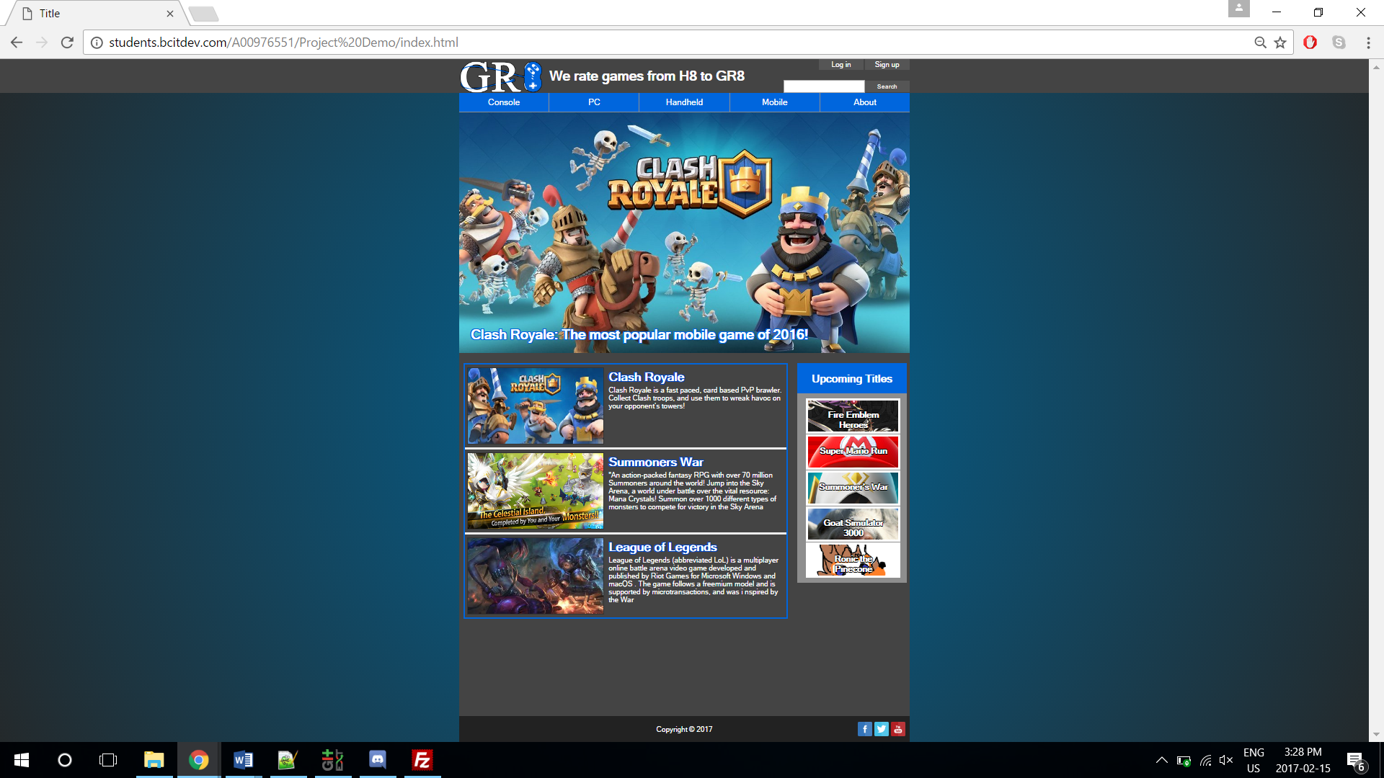

**2.2 Screenshots of table**

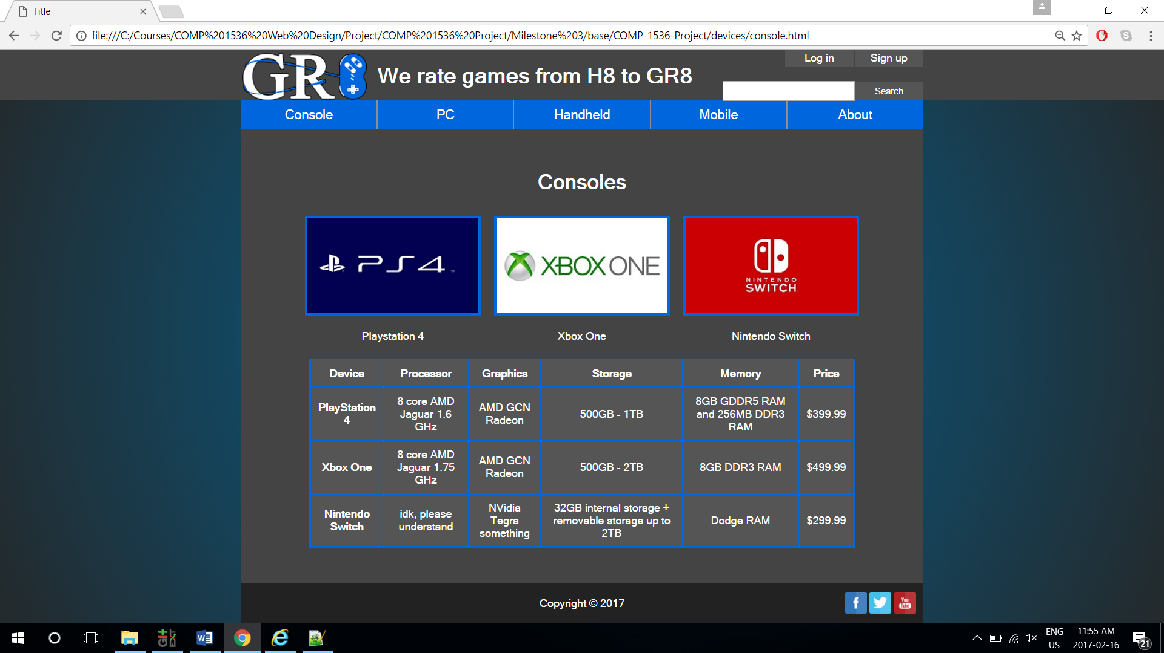

**2.3 Screenshots of form**

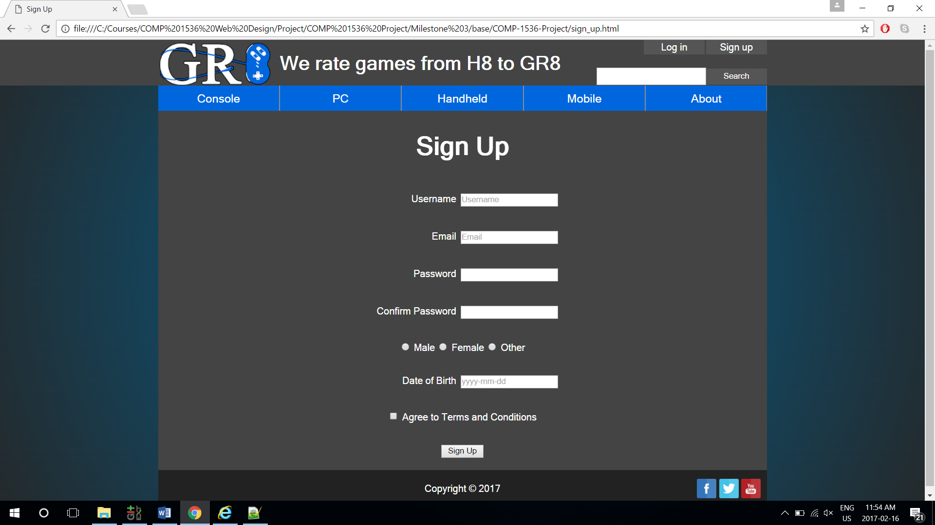

**3.Key issues**

**3.1 Encountered problems**

During the development of our webpages, we found that the initial design scales poorly on different screen resolutions. Therefore, we adjusted the website structure from being static to window rescaling to responsive. Also, we used media query and viewport to adjust the elements of the website to fit on a mobile device.

**3.2 Outstanding problems**

Our current issues mainly revolve around dynamic web elements, such as having a log in bar pop up when clicking the log in page, and having only the navigation bar stay static at the top when scrolling down. These issues can be resolved when we apply JavaScript to our website.

**4.Testing**

**4.1 A/B testing**

We conducted A/B testing on our discord group, which consists of other project group members. We thought having subjects with experience with web design would provide us with more critical feedbacks.

The test was conducted with Strawpoll over discord. The subjects were given two different links to two websites with different layouts, and were asked to vote for the layout that they felt was better after they were given ample time to navigate through each, they were also required to give reasons for their vote.

The results were convincing, with a 83% (10 out of 12) vote for design 1. Most subjects thought the contrast between the border and background gradient is more pleasant to view, and the blue subject titles help highlight each individual article.

**4.2 Accessibility testing**

We conducted numerous accessibility testing throughout the skeleton page development. We ensured that the pages were compatible with four major browsers: Internet Explorer, Mozilla Firefox, Microsoft Edge, and Google Chrome. Also, we employed responsive design to let our pages adjust dynamically per the display, which results in a great mobile layout without needing to create separate CSS style sheets for it.

**4.2.1 Browser compatibility**

We tested our pages on four primary browsers, the Internet Explorer, Mozilla Firefox, Microsoft Edge, and Google Chrome. The pages could run properly on all four browsers, and the pages look consistent throughout each browser.

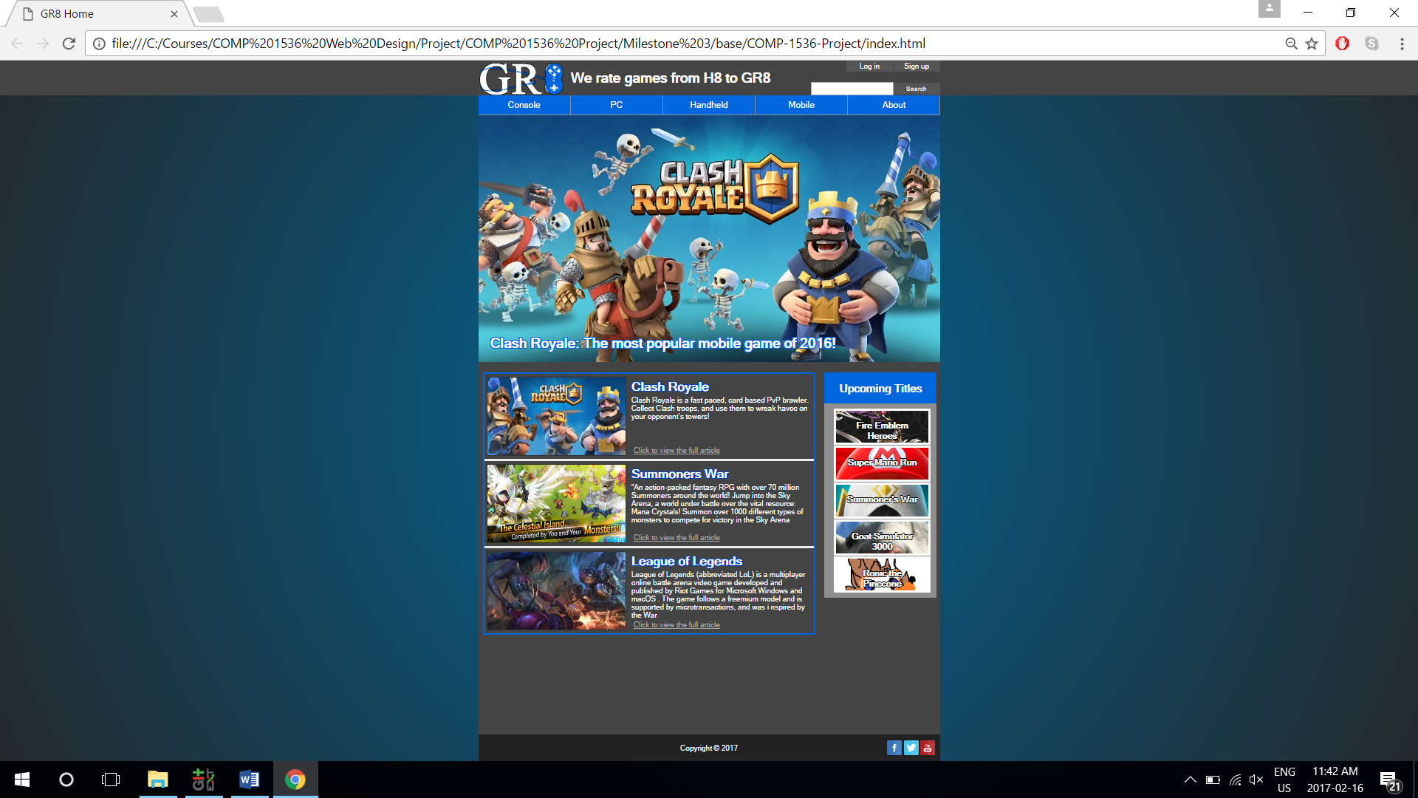

Page displayed on Chrome

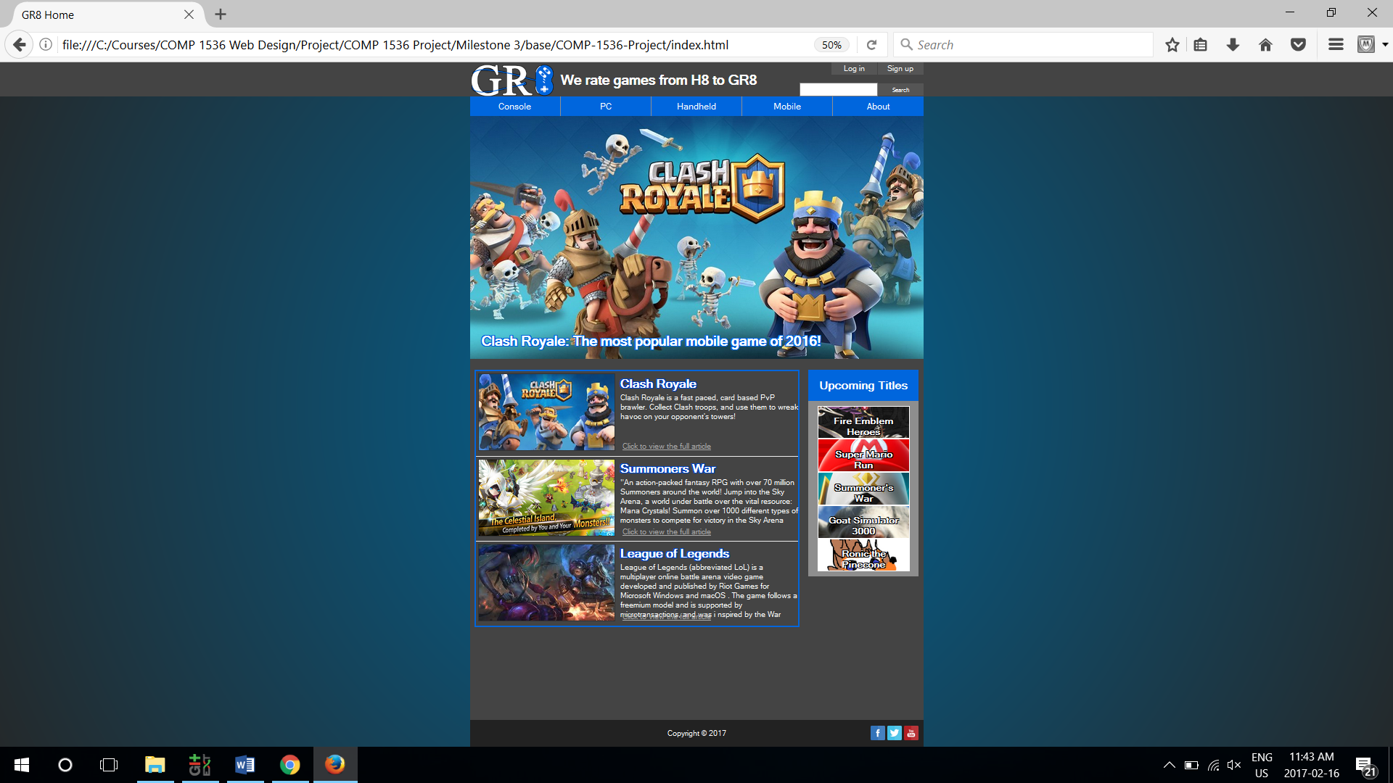

Display on Firefox

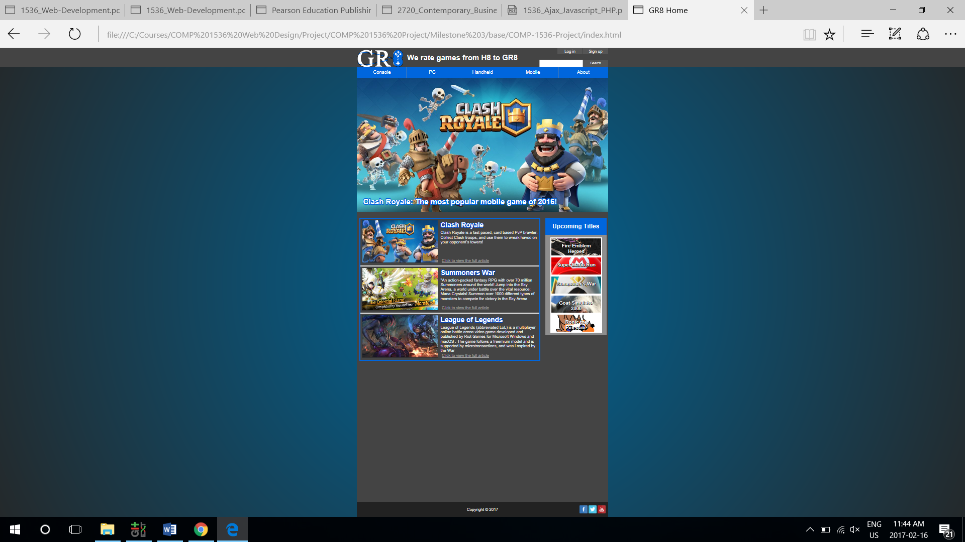

Display on Edge

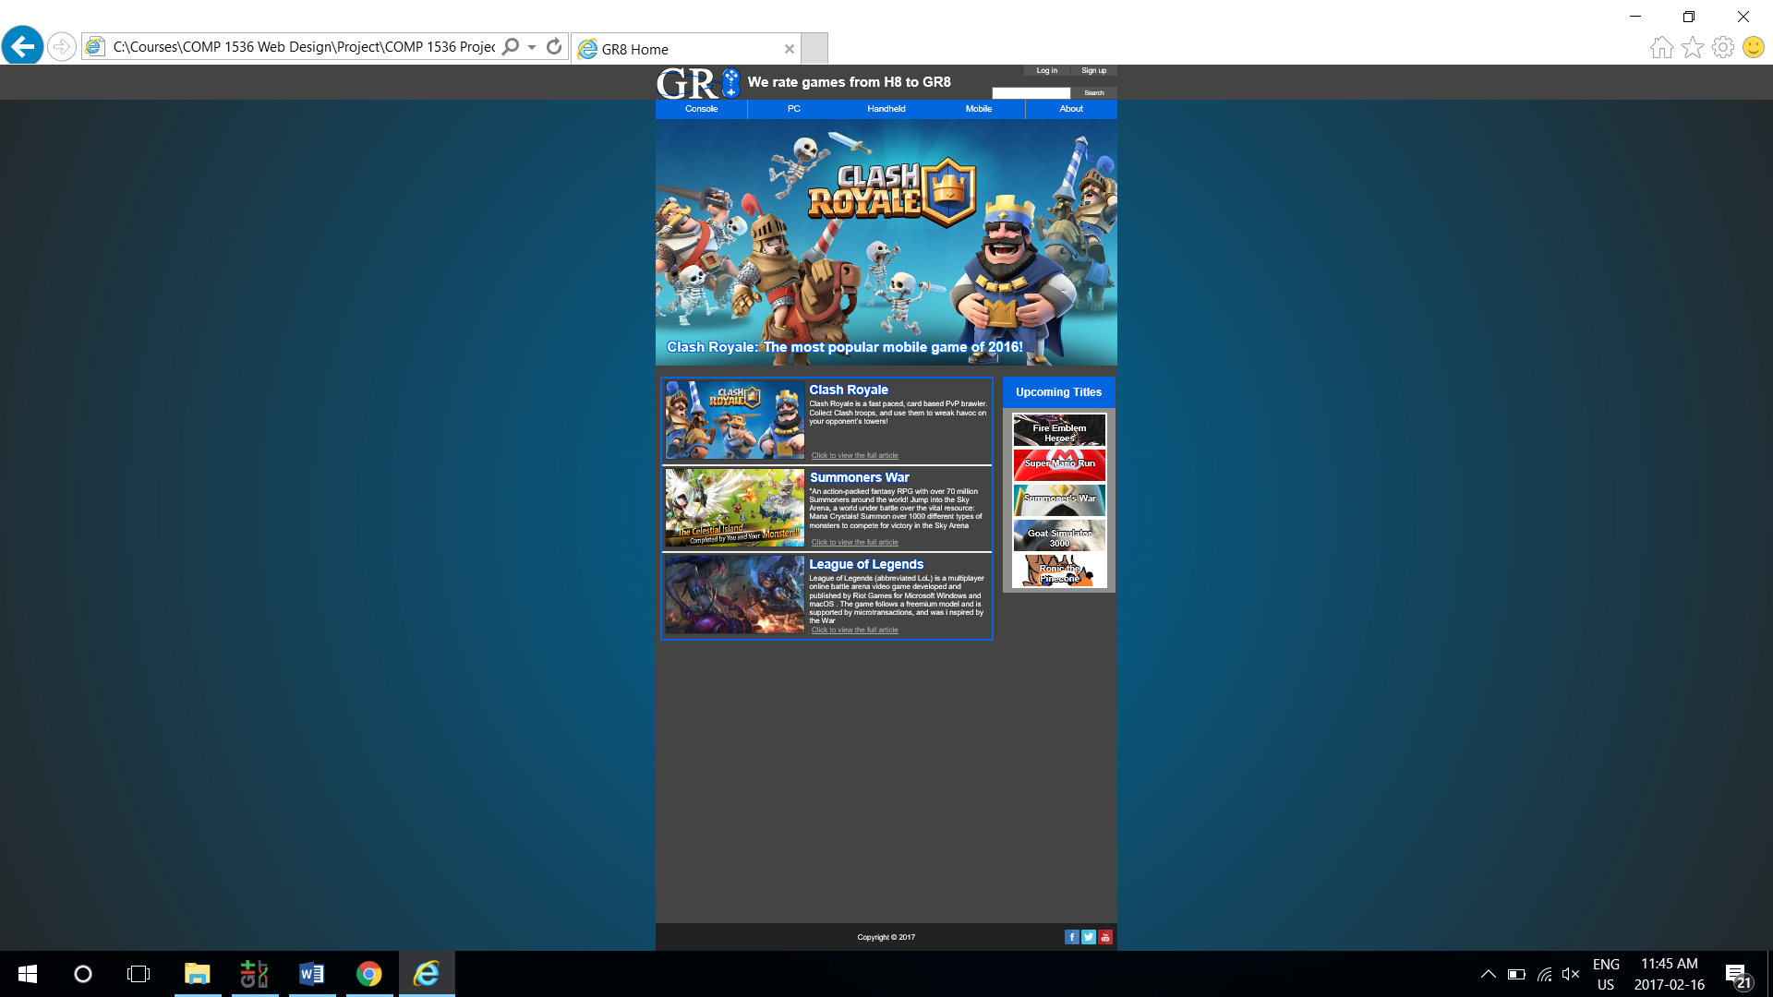

Display on Internet Explorer

**4.2.2 Device compatibility**

The pages were also tested on mobile devices. We used Chrome’s inspector to test for responsiveness, and used iPhone 6s and Android phones to test out the actual webpages. Some elements such as the slogan and log in/sign up buttons will scale per page size, and behave differently in different sizes. This allows us to display our website nicely in various screen resolutions.

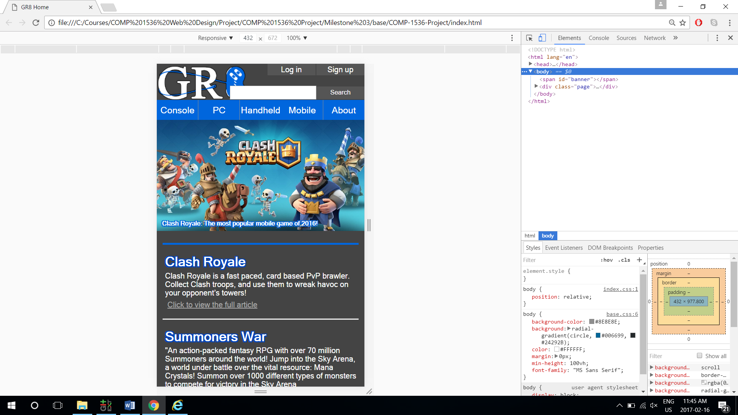

Page on mobile display

**4.3 HTML/CSS validation**

All pages pass the HTML 5 and CSS validation.